**INTRODUCTION**

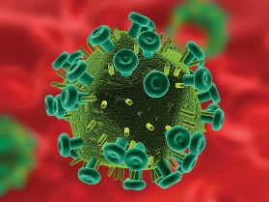The **human immunodeficiency virus**, or **HIV**, is a relatively new pandemic, responsible for causing AIDS and killing millions of people around the world. It belongs to a family of retroviruses known as lentiviruses, which are found in a number of non-human primates.

**HIV**

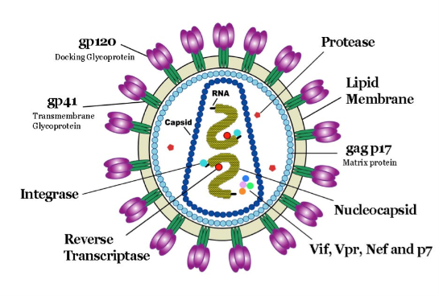In humans, HIV attacks the body’s immune system, specifically the CD4 cells (T cells), which help the immune system fight off infections. If left untreated, HIV reduces the number of CD4 cells (T cells), getting to a point where the body can’t fight off infections and diseases. AIDS is defined as the stage of HIV infection when your CD4 counts fall below 200 cells per cubic millimeter of blood.

**HIV Structure**

HIV is also divided into 2 main types – HIV-1 and HIV-2. More well-known is the former; it is responsible for the vast majority of AIDS cases and has spread worldwide while HIV-2 is prevalent mainly in West Africa and is less pathogenic.

In order to track evolutionary relationships and rates/dates of divergence, scientists have created phylogenetic trees with both subtypes of HIV-1 and 2. In doing so, scientists have discovered that HIV evolved from **simian immunodeficiency virus**, or **SIV**, a closely related disease found in non-human primates.

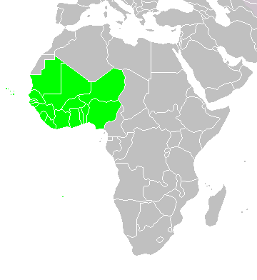However, many of the trees are of either low or unpublished bootstrap and/or posterior probability, both of which are indicators of a strong tree. Much focus has also been put on tracking the subtypes of HIV-1 and 2 more common in the Western world, and not so much in the rest of the world. As a result, a decision was made to create a very well-supported tree with HIV-1, HIV-2 and SIV sequences from West Africa, where the disease is believed to have originated. With succinct evolutionary relationships, medicine and treatments can be focused on certain unchanging or weak areas in the virus.

**Map of West Africa**